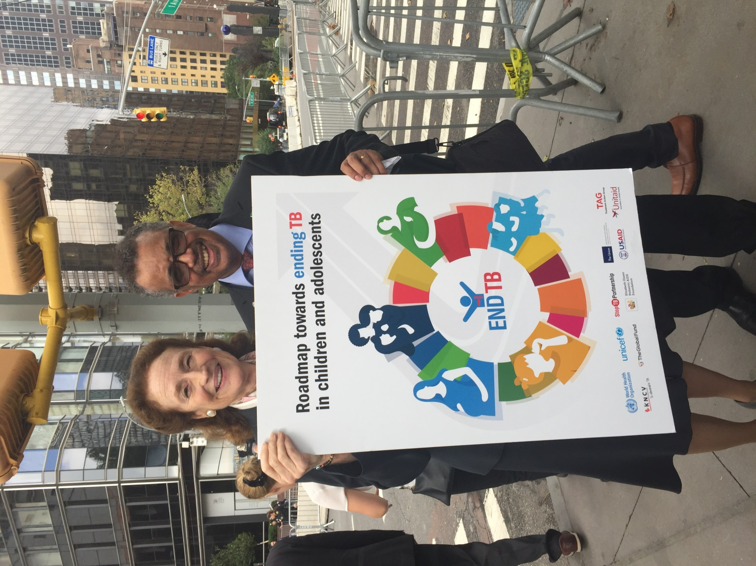

Henriette Fore (Executive Director, UNICEF) and Tedros Adhanom Ghebreyesus (Director General, WHO) holding the Roadmap poster

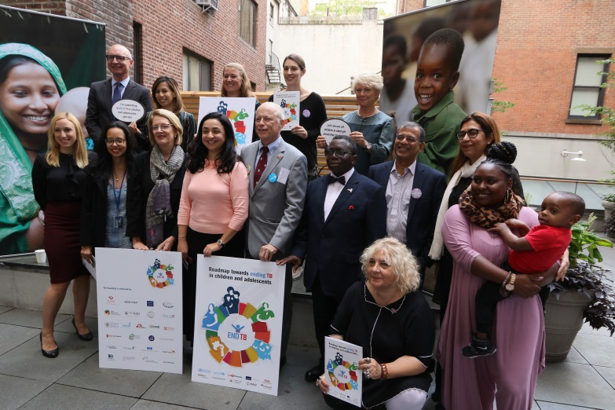 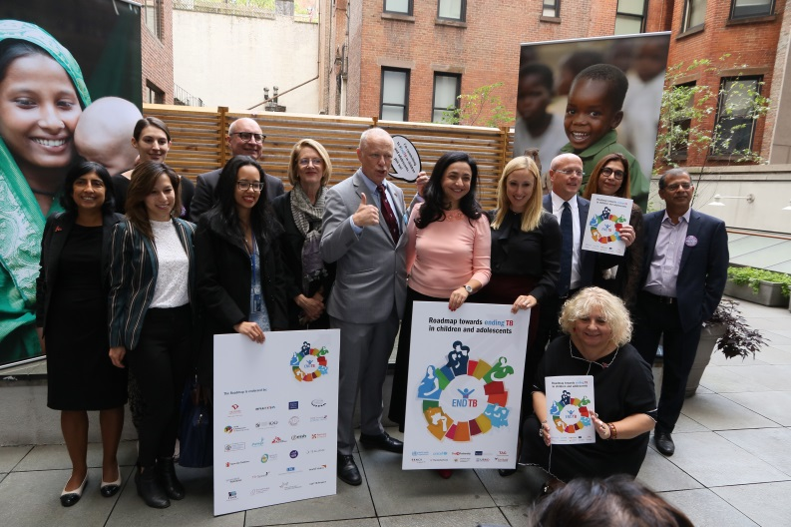

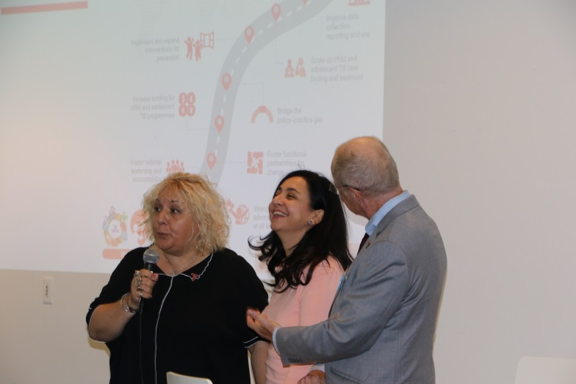 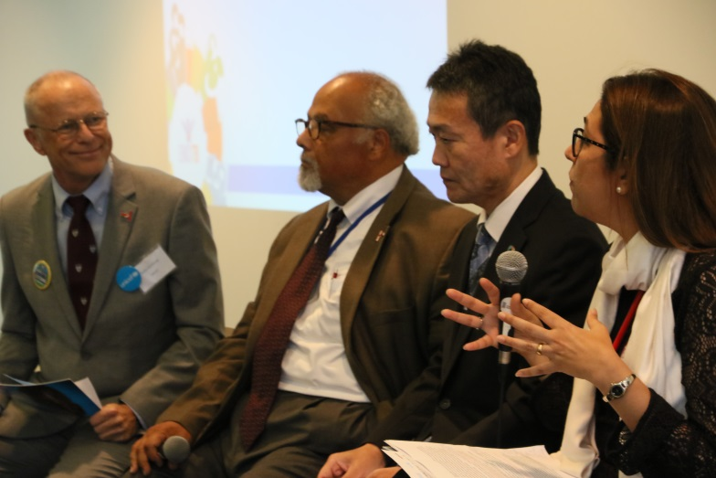

|  |  |
| --- | --- |
| Opening address by Stefan Peterson, Tereza Kasaeva and Lucica Ditiu | Panel 1 with Eric Goosby, Junya Nakano and Farhana Amanullah, moderated by Stefan Peterson |

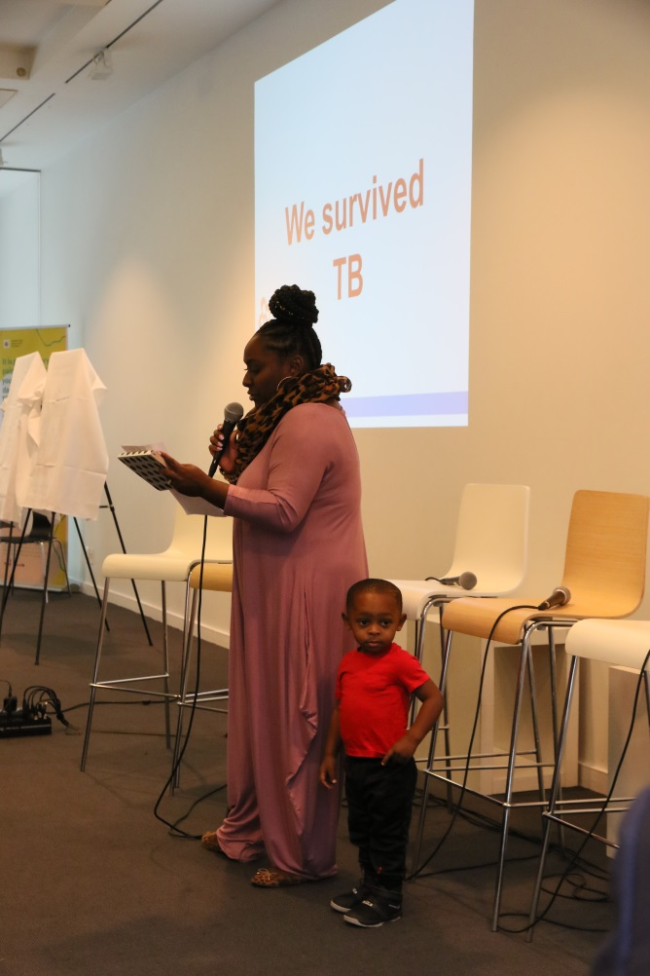 Jackson East with mother Kristine East

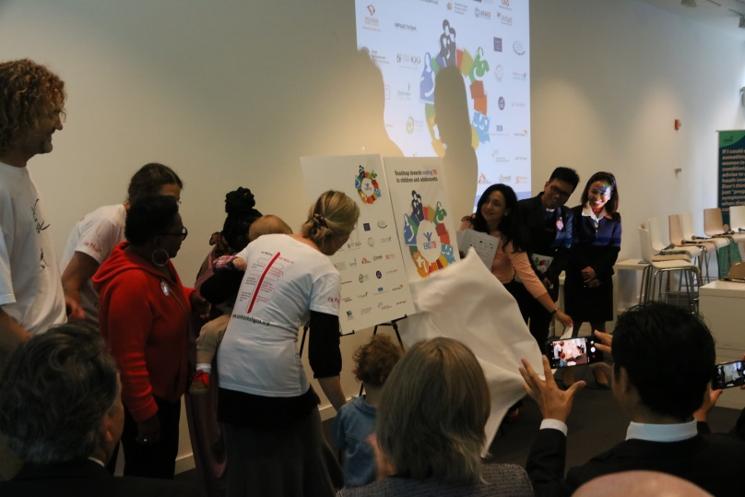 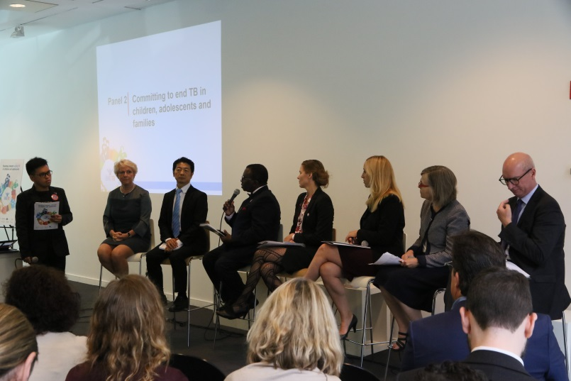

|  |  |
| --- | --- |
| Launch of the Roadmap, with Tereze Kasaeva, Jeff Acaba, Jackson and family, Arne and Dalene von Delft with family | Panel 2 with Isaac Adewole, Ellen Trane Nørby, Janet Ginnard, Irene Koek, Osamu Kunii, Kitty van Weezenbeek and José Luis Castro, moderated by Jeff Acaba |

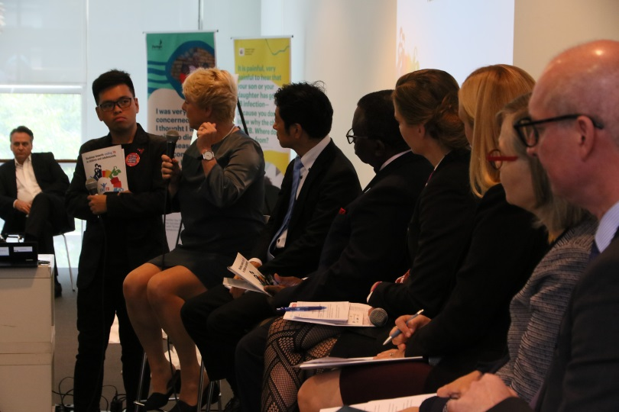

 

Resources:

Roadmap towards ending TB in children and adolescents: <http://www.who.int/tb/publications/2018/tb-childhoodroadmap/en/>

Best Practices in child and adolescent tuberculosis care: <http://apps.who.int/iris/bitstream/handle/10665/274373/9789241514651-eng.pdf>

Research priorities for paediatric tuberculosis: <http://www.treatmentactiongroup.org/content/research-priorities-pediatric-tuberculosis>